|  |  |
| --- | --- |
| **Radiocommunication Study Groups** |  |
|  |  |
|  |  |
| Received: Date 2018  Subject: | **Document -E** |
| **Date 2018** |
| **English only** |
| Brazil (Federative Republic of) | |
| AGGREGATE INTERFERENCE PROTECTION TO DIGITAL TERRESTRIAL TELEVISION SERVICE SHARING uhf FREQUENCY BAND WITH WHITE SPACE DEVICES | |
|  | |

1. **Introduction**

The European regulatory body CEPT (European Conference of Postal and Telecommunications Administrations) produced, through its ECC (Electronic Communications Committee) study group, report ECC.186 [1] containing technical and operational requirements for the implementation of WSD (White Space Devices) systems in the DTT (Digital Terrestrial Television) frequency bands. This report contains studies and results on cognitive techniques and concludes that the use of a geolocation database is the viable solution for operating WSD systems.

In addition, a methodology for calculating the maximum allowable emission power for a WSD was developed based on a maximum degradation value for the location probability (a known coverage performance parameter used in the DTT planning process). The choice of an specific value for this maximum degradation as well as the choice of the values of some other parameters are left to each national regulatory authority (NRA). After that, ECC published the report ECC.236 [2] given a guidance for national implementation of a regulatory framework for WSD using geolocation databases.

The Ofcom (UK regulatory authority) published the first European regulation [3] allowing WSD systems to operate in the DTT band through the support of a geo-database system. It defines a methodology to calculate the maximum WSD transmission power, based on single-entry interference. One of the assumptions in this methodology is that only one WSD will radiate per cell (called pixel in regulation) and per frequency channel. The Ofcom regulation recognizes that a WSDB (White Space Database) can provide service for multiple WSDs operating in the same geographic area and in the same frequency channel, resulting in an aggregation of interference. However, the regulation assumes that aggregation of multiple WSD interferences will not be a problem in the short-term.

The methodology and assumptions used by the Ofcom regulation follow the traditional approach of defining a single-entry interference limit. However, in a scenario involving opportunistic systems, the use of a single-entry interference limit may be insufficient to ensure that the aggregate interference power does not exceed the regulatory limit, as demonstrated in [4]. This problem is addressed in here through a new methodology that guarantees the protection of DTT receivers from aggregate WSD interference.

1. **Problem Description**

The Ofcom regulation annexes [5] defines a methodology to determine the maximum allowed WSD transmission power. It takes into account the design of DTT system, which is done by dividing the DTT service area into small cells of 100m x 100m and associating to each cell, a coverage quality parameter called location probability. The location probability calculation is based on the intrasystem interference power from digital TV transmitters. The design of DTT system defines this interference by curves of the power exceeded 1% of time.

The use of the DTT frequency band by WSDs generates intersystem interference which degrades the location probability associated with several of the cells. According to the Ofcom regulation, this degradation is expected to be less than 7%. Let then $Z_{j}$ be the intersystem interference power that produces a 7% location probability degradation on cell $j$. The value of $Z_{j}$ for each cell in the DTT service area can be calculated as developed in [5]. In this work, we assume that the values of $Z_{j}$ is known for each cell in the DTT service area.

The maximum aggregate transmission power (e.i.r.p. -- equivalent isotropically radiated power) of all WSDs in a cell is calculated by ensuring that the interference power produced by the WSDs is lower than the $Z_{j}$ values associated with the cells in the region of interest.

According to the annexes of the Ofcom regulation, for adjacent channel interferences, the maximum aggregate WSD e.i.r.p. allowed in a cell $k$ must be such that the interference it produces in Cell $j$ is less than or equal to $Z_{j}$, for all cells in a circular area of 2 km radius. The geometry in Figure 1 illustrates a cell $k$ (containig the interfering WSDs) and a cell $j$ within the circular area $S_{k}$.

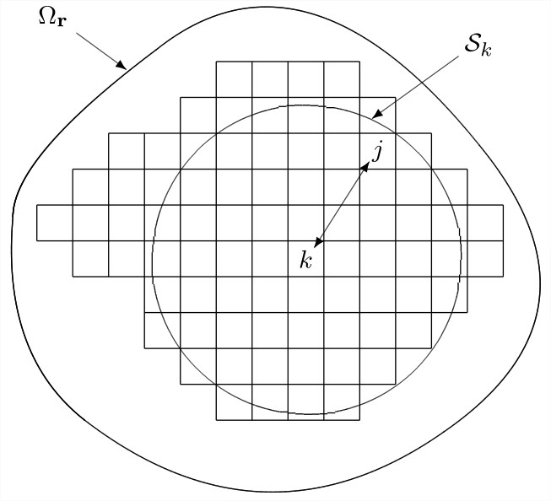

Figure 1. Geometry to determine the maximum e.i.r.p. $E_{k}$

In the figure, $Ω_{r}$ characterizes the working region. The calculation of the maximum e.i.r.p. $E_{kj}$ for the WSDs in cell $k$ is given by

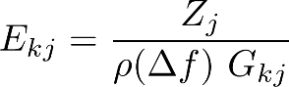 (1)

where $G_{kj}$ is known as coupling gain that accounts for the joint effect of the propagation loss due to the distance between cell $k$ and cell $j$ and the gain of the antenna associated with the angle of arrival of the interference with respect to the direction of DTT antenna pointing, $ρ(Δf)$ is the protection rate relative to the frequency separation $Δf$ between the frequency channels of the DTT and the WSD.

After calculating all $E_{kj}$ associated with all the cells in $S_{k}$, the maximum regulatory e.i.r.p. $E_{k}$ for the WSDs in Cell $k$ is given by

http://latex2png.com/output/latex_60bf38ff6864024e0793863358e34864.png (2)

Observe that the methodology to calculate $E_{k}$ is given by a single-entry approach, that is, it is not considering the interference from other cells within the circular area $S_{k}$.

1. **Mathematical Model**
   1. **New Maximum e.i.r.p. and Most Vulnerable Cell**

In DTT design, the intrasystem interference power is considered as the power exceeded 1% of the time. However, the intersystem interference power $Z$, as considered by the Ofcom methodology, do not adopt this definition. In the methodology proposed here, the intersystem interference power $Z$ is treated in the same way as the intrasystem interference power, that is, $Z$ corresponds to the power level exceeded 1% of the time. Although the regulatory e.i.r.p. for the WSDs in cell $k$ is here given by (2), the values of $E_{kj}$ are not calculated as indicated in (1). To determine the values of $E_{kj}$, consider Figure 2 and let $i_{kj}$ denote the interfering power produced by the WSDs in cell $k$ at a DTT receiver located at the center of Cell $j$.

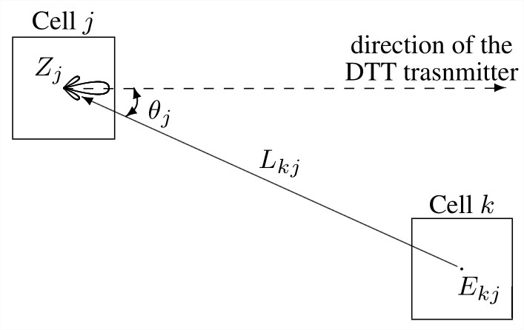

Figure 2. Geometry to determine the maximum e.i.r.p. $E_{k}$ considering $Z_{j}$ as the power level exceeded 1% of the time.

This interfering power is given by

http://latex2png.com/output/latex_35028abc0fa172059ba7cdec87a0e52e.png (3)

where $E_{kj}$ is the e.i.r.p. transmitted by the WSDs in cell $k$ in the direction of cell $j$, $L_{kj}$ is the propagation loss experienced by the WSDs transmissions, $g(θ_{j})$ is the DTT receiving antenna gain in the direction of cell $k$ (in dBi) an $ρ(Δf)$ d represents the protection ratio (in dB) required to protect the wanted signal from interference when the interfering and the desired frequency channels are $Δf$ Hz apart.

The propagation loss $L_{kj}$ is given by the extended Hata model [6], being modeled as a gaussian random variable with mean $m_{kj}$ and standard deviation $σ_{kj}$. The linear relation in (3) indicates that $i_{kj}$ is also a gaussian random variable, with mean and standard deviation given by

http://latex2png.com/output/latex_b3ebee8d3d77d7fbed9262c6e38548b4.png (4)

Note that, as $Z_{j}$ represents the interference power level exceeded 1% of the time, the interference $i_{kj}$ must satisfy the condition $P\left(i_{kj}>Z_{j} \right)≤0.01$ which, considering that $i_{kj}\sim N(m_{kj}^{'}, σ_{kj}^{'} )$, can be written as

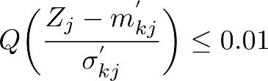 (5)

with $Q(∙)$ denoting the well known $Q$-funcion [7]. Noting that the $Q$ is a decreasing function and that $Q\left(2.33\right)=0.01$, the condition in (5) becomes

http://latex2png.com/output/latex_8c942925b8096d479b3d21e589159a44.png (6)

Finally, considering (2),

http://latex2png.com/output/latex_31f49f20b2498838b3539575749f4d5f.png (7)

Note that the value of $j$ that corresponds to the minimum in (7) identifies the most vulnerable cell (MVC) associated with cell $k$. Whether a WSD in cell $k$ increases its e.i.r.p. above $E_{k}$, the associated MVC will be the first cell to have its intersystem interference power $Z_{MVC}$ exceeded.

Considering the MVC as the interfered victim cell, if a interference threshold (or criterion) is satisfied in MVC, all cells within the circular area $S_{k}$ would have the threshold satisfied. Therefore, a new WSD, admitted in cell $k$, should only meet the interference criterion in MVC to satisfy the same criterion for all the cells in .

* 1. **Aggregate interference**

To calculate the aggregate interference power reaching the DTT victim receiver, consider the geometry in Figure 3.

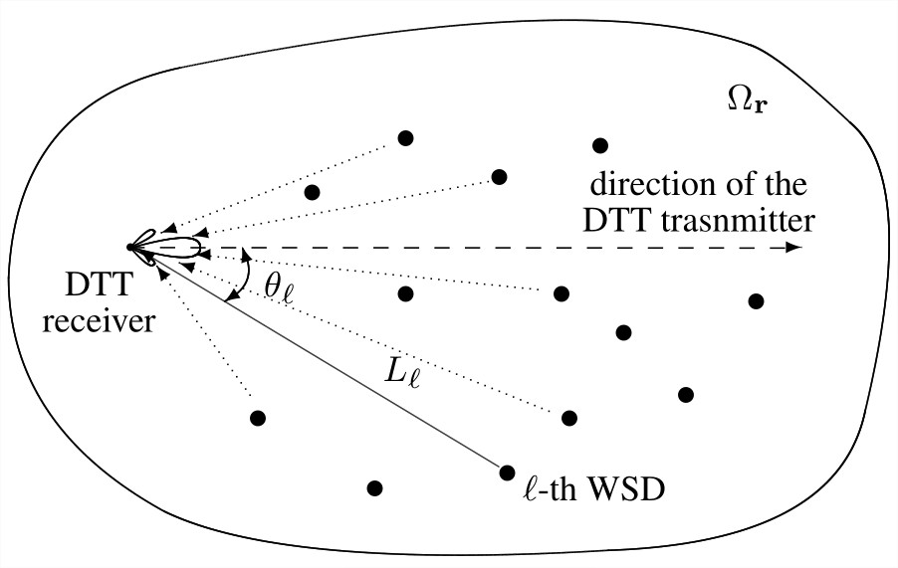

Figure 3. Geometry to determine the WSD aggregate interference.

Let the interference power $i_{l}$ due to a single $l$-th WSD, expressed in dBm, be written as

http://latex2png.com/output/latex_ab09d60ffd2abf18ec54d755924d51d7.png (8)

where $P_{l}$ denotes the e.i.r.p. transmitted by the interfering WSD (in dBm), $L_{l}$ is the propagation loss experienced by the WSD transmission (in dB), $g(θ_{l})$ is the DTT receiving antenna gain in the direction of the $l$-th WSD (in dBi) and $ρ(Δf)$ is defined the same way as in (3). Again, the propagation loss $L_{l}$ is given by the extended Hata, being then modeled as a gaussian random variable, implying that $i_{l}$ is also a gaussian random variable. Assuming $N$ interfering WSDs, the aggregate interference power $i_{agg}$ reaching the DTT receiver, expressed in dBm, is written as

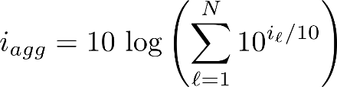 (9)

The expression within parentheses in (9) corresponds to a sum of statistically independent lognormal random variables [8]. Determining the probability density function (PDF) of the sum of lognormal random variables is a complex task. However, an approximation can be obtained by using the Schwartz-Yeh (SY) algorithm presented in [9] and numerically improved in [10]. In the SY algorithm, the PDF of the sum of lognormal random variables is approximated by a Lognormal PDF, implying that $i_{agg}$ is a gaussian random variable.

Now, let $r_{l}$ be a two-dimensional vector containing the longitude and latitude of the geographical location of the $l$-th interfering WSD and $r={\left(r_{1}^{T} r_{2}^{T} ⋯ r_{N}^{T}\right)}^{T}$ be the vector containing the geographical locations of all interfering WSDs. The complementary probability distribution function of $i_{agg}$ can then be written as

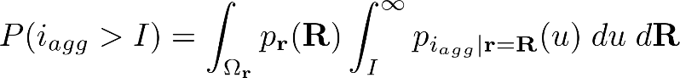 (10)

Note that the inner integral in (10) represents the conditional complementary probability distribution function of $i_{agg}$, $P(i_{agg}>I|r=R)$. Observe that given the positions of all interfering WSDs ($r=R$) and knowing the conditional means $m_{i_{l}|r=R}$ and the conditional standard deviations $σ_{i_{l}|r=R}$ of all interference entries, the SY algorithm provides de conditional mean $m_{i_{agg}|r=R}$ and the conditional standard deviation $σ_{i_{agg}|r=R}$ of the gaussian random variable characterizing the aggregate interference $i_{agg}$. In this case, this conditional complementary distribution function becomes

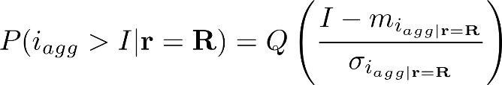 (11)

* 1. **Interference criterion**

As indicated before, in this work, $Z_{j}$ represents the interference power level exceeded 1% of the time. Here, we consider that, given $r=R$, the aggregate interference $i_{agg}$ must satisfy the interference criterion

$P(i_{agg}>Z_{j}|r=R)≤0.01$ (12)

for all cells within the working region $Ω_{r}$. Let $I_{0.01}$ denote the aggregate interference power level exceeded with probability $0.01$ when $r=R$, that is, $I_{0.01}$ must satisfy the condition

$P\left(i_{agg}>I_{0.01} | r=R\right)=0.01$ (13)

Note that the condition in (12) is satisfied whenever $Z_{j}≥I_{0.01}$, indicating that an equivalent interference criterion would be

$I_{0.01}≤Z_{j}$ (14)

for all cells within the working region $Ω_{r}$. Observe that, considering (11), the solution of (13) for $I_{0.01}$ can be shown to be

http://latex2png.com/output/latex_ded25fe723e832e145746fb1191eaf47.png (15)

1. **Admission Procedures**

In this section, the admission procedures based on Ecc.186 and Ofcom methodologies are presented, as well the proposed admission procedure, here called Iagg. Descriptions of these three admission procedures are presented in the following subsections. In all procedures, it is assumed that an admission request is made by a new WSD located at the center of Cell 0 which is located at the center of the WSDs operating region.

* 1. **Admission Procedure Based on Ecc.186**

The admission procedure based on the Ecc.186 methodology (AP-Ecc.186) was developed using the ECC.186 report [1]. A diagram of the procedure is shown in Figure 4.

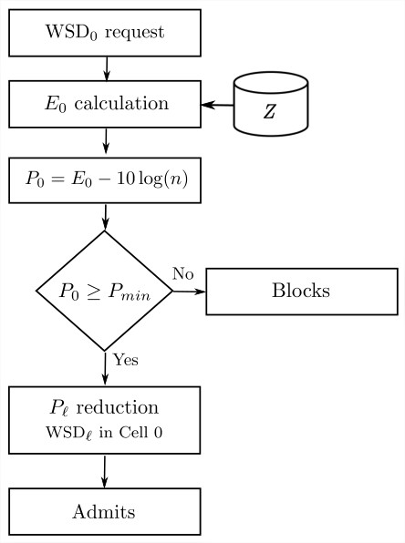

Figure 4. Admission procedure based on the Ecc.186 (AP-Ecc.186).

The procedure begins with an admission request by a new WSD (${WSD}_{0}$) and the calculation of the regulatory e.i.r.p. $E_{0}$ associated with Cell 0 as shown in Section 3.1. The operating e.i.r.p. $P_{0}$ of the ${WSD}_{0}$ is determined by dividing $E_{0}$ by the total number $n$ of WSDs in Cell 0, that is,

$P_{0}=E_{0}-10\log\left(n\right)$ (16)

when expressed in dBm. Note that all WSDs in Cell 0 will be the operating with an e.i.r.p. of $P_{0}$ dBm. Note that the operation of ${WSD}_{0}$ can only start after all already operating WSDs in Cell 0 have their e.i.r.p reduced to $P_{0}$. This may imply in an increase in admission time, as analysed in Section 4.4.

As a reduction in the WSD transmission power may lead to a reduction in the transmitted information rate, a minimum operational e.i.r.p. $P_{min}$ is set so that the WSDs can operate at a suitable transmission rate. If $P_{0}$ is greater than the minimum operational e.i.r.p. $P_{min}$, the ${WSD}_{0}$ is admitted. Otherwise, ${WSD}_{0}$ is blocked.

* 1. **Admission Procedure Based on Ofcom**

The Ofcom methodology considers that, in general, the WSDs operate with e.i.r.p. which are less than the maximum regulatory e.i.r.p. $E_{k}$. This premise allows for a probabilistic approach in which the WSDs e.i.r.p. are modeled as gaussian random variables. In this case, the sum of the e.i.r.p. of the WSDs within a single cell is also a gaussian random variable. The admission procedure based on the Ofcom methodology (AP-Ofcom) requires that the probability of having this random variable greater than the regulatory e.i.r.p $E_{k}$ has a small value. In the case of Cell 0, for example, it could be required that

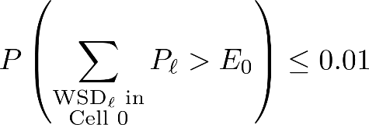 (17)

As illustrated in Figure 5, this is the main difference between the AP-Ofcom and the AP-Ecc.186.

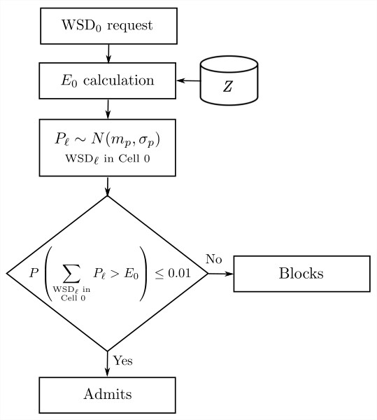

Figure 5. Admission procedure based on the Ofcom (AP-Ofcom).

Note that in this admission procedure the actual values of the WSDs e.i.r.p. are not used since they are modeled as random variables. As a consequence, there is no need to change the e.i.r.p. of the already operating WSDs and no increase in admission time.

* 1. **Iagg Admission Procedure**

The AP-Ecc.186 and AP-Ofcom aim to satisfy the constraint imposed by the regulatory e.i.r.p. associated with each cell. However, as indicated in [4], this does not guarantee that the aggregate interference criterion in (12) is satisfied. To avoid this problem, the proposed admission procedure (AP-Iagg) takes into account the WSDs aggregate interference by considering the criterion in (12) or, equivalently, that in (14). In the Iagg admission procedure the aggregate interference criterion in (14) is checked only for the most vulnerable cell (MVC) associated with the WSD requesting admission in Cell 0. A diagram of AP-Iagg is shown in Figure 6.

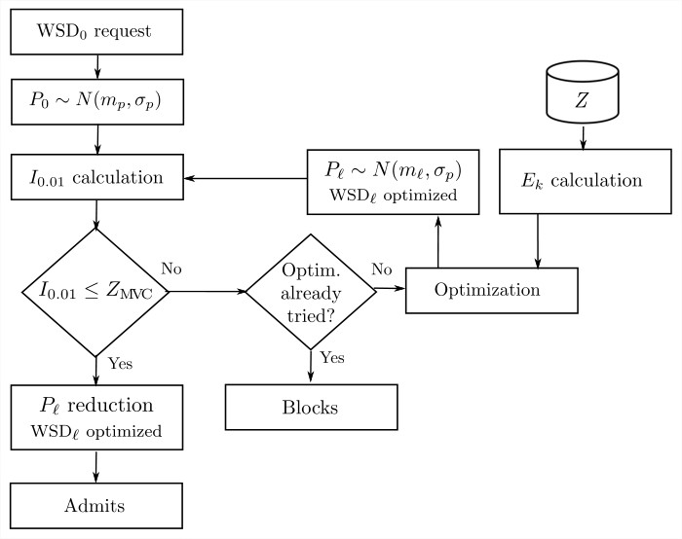

Figure 6. Iagg Admission procedure (AP-Iagg).

As in the AP-Ofcom, this procedure models the WSD e.i.r.p. $P_{l}$ as a gaussian random variable. In the beginning, the ${WSD}_{0}$ e.i.r.p. $P_{0}$ is considered with the same mean and standard deviation of the e.i.r.p. $P_{l}$ in AP-Ofcom. The aggregate interference power exceeded 1% of the time $I_{0.01}$ is calculated using (15) with $m_{i_{agg}|r=R}$ and $σ_{i_{agg}|r=R}$ determined by the SY algorithm [9] [10].

If the interference criterion in (14) is satisfied, the ${WSD}_{0}$ is admitted. If not, an optimization of the $P_{l}$ mean values is performed. In this case, the $P_{l}$ mean values $m_{l}$ obtained after optimization is used to recalculate the $I_{0.01}$. The interference criterion is evaluated once more. If (14) is satisfied, the optimized WSDs e.i.r.p. $P_{l}$ are reduced and the ${WSD}_{0}$ is admitted.

* + 1. **Optimization**

The optimization in the AP-Iagg procedure provides a selective reduction of the WSDs e.i.r.p. in a tentative to meet the interference criterion, so that ${WSD}_{0}$ is admitted. In the process, the mean values $\{m_{l}, l=1,⋯, N\}$ of the e.i.r.p. $\{P_{l}, l=1,⋯, N\}$ are optimized, but still guaranteeing a low probability that the e.i.r.p. $P_{l}$ be out of the minimum and maximum limits $[P_{min}, E_{k}]$, that is, $P\left(P_{l}<P_{min}\right)<0.01$ and $P\left(P_{l}> E_{k}\right)<0.01$. These constraints imply in lower and upper bounds for the mean e.i.r.p., which are given by

$M_{l,min}=P_{min}+2.33σ_{p}$ (18)

$M_{l,max}= E_{k}-2.33σ_{p}$ (19)

Note that our goal is to reduce the difference $I_{0.01}- Z_{MVC}$ to zero, in order to meet the interference criterion. We then define an optimization problem having as the objective function

http://latex2png.com/output/latex_f83498867155095b72a492841685f69a.png (20)

with $m={(m_{1}, m_{2}, ⋯, m_{N})}^{T}$. This nonlinear function is to be minimized under the constraints imposed by the lower and upper limits in (18) and (19). In summary the problem to be solved is given by

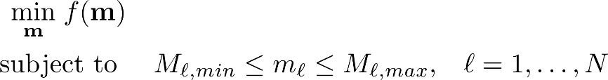 (21)

Note that it is possible to have an optimal solution that do not achieve the objective of $I_{0.01}= Z_{MVC}$ due the problem constraints. In this case, ${WSD}_{0}$ is not admitted. In the results presented in Section 5, this optimization problem was solved using the Trust Region Method described in [11] [12] [13].

* + 1. **Average Admission Time**

The average admission time $T_{ad}$ represents a cost associated with AP-Ecc.186 and AP-Iagg, since they require additional admission times so that the operating WSDs can reduce their e.i.r.p. before ${WSD}_{0}$ starts its operation. For the AP-Ecc.186, this delay is associated with the WSDs operating in the same cell as the ${WSD}_{0}$, which have to reduce their operating e.i.r.p. to allow for the operation of ${WSD}_{0}$. In the case of AP-Iagg the delay is related to the WSDs having their e.i.r.p. reduced in the optimization process. Note that the admission time, as considered in this section, do not include the amount of time usually used for the handshaking between ${WSD}_{0}$ and the WSDB.

To determine the average admission time, let

$E=$ { ${WSD}_{0}$ requests admission when the number of WSDs operating in Cell 0 is zero}

$\overline{E}=$ { ${WSD}_{0}$ requests admission when the number of WSDs operating in Cell 0 is greater than zero}

be events associated with AP-Ecc.186 and

$M=$ {The aggregate interference criterion is met when the interference due to ${WSD}_{0}$ is considered}

$\overline{M}=$ {The aggregate interference criterion is not met when the interference due to ${WSD}_{0}$ is considered}

be events associated with AP-Iagg.

In the following mathematical development, let $X$ represent either the events $E$ or $M$, and $\overline{X}$ represent either the events $\overline{E}$ or $\overline{M}$. Let $t$ be the random variable representing the ${WSD}_{0}$ admission time. The Total Probability Theorem allows the probability density function (PDF) of $t$ to be written as

http://latex2png.com/output/latex_68fbf2fa82c6d7af49aada11638f5aea.png (22)

with $p_{t|X}(T)$ and $p_{t|\overline{X}}(T)$ denoting the conditional PDFs of $t$, given the occurence of $X$ or $\overline{X}$, respectively, and with $P(∙)$ denoting probability. Note that when $X$ ( $E$ or $M)$ occurs, the admission time is zero ( $t$ is equal to zero with probability 1). In this case

$p_{t|X}\left(T\right)=δ(T)$ (23)

with $δ(∙)$ denoting the Dirac delta function. When $\overline{X}$ ( $\overline{E}$ or $\overline{M}$) occurs, however, the ${WSD}_{0}$ must wait until all affected WSDs reduce their power.

To determine the conditional PDF of $t$, given $\overline{X}$, let $∆$ denote the WSD returning period, that is, the period in which the WSDs admitted in the system periodically return to the WSDB to revalidate parameters and remain in the frequency channel. Also, let $τ_{i}$ be the time interval between the ${WSD}_{0}$ request time $t_{{WSD}_{0}}$ and the returning time, $t_{{WSD}_{i}}+∆$, of ${WSD}_{i}$ (see Figure 7).

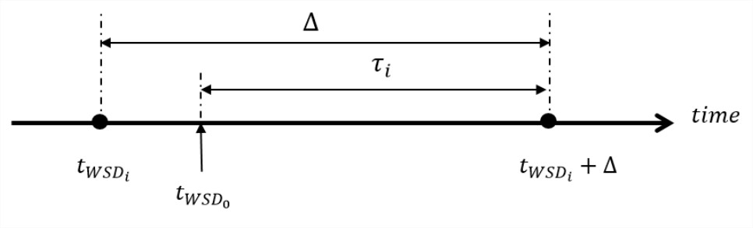

Figure7. Time interval between the ${WSD}_{0}$ request time and the returning time of ${WSD}_{i}$.

Note that, given $\overline{X}$, the admission time is written as

http://latex2png.com/output/latex_77c32cb71ebfd2e18cc7cb80ea099b33.png (24)

with $n$ being the number of affected WSDs. It is assumed here that $\{τ_{i}, i=1…n\}$ are independent and identically distributed (i.i.d.) random variables, uniformly distributed in the interval $[0, ∆]$. In this case,

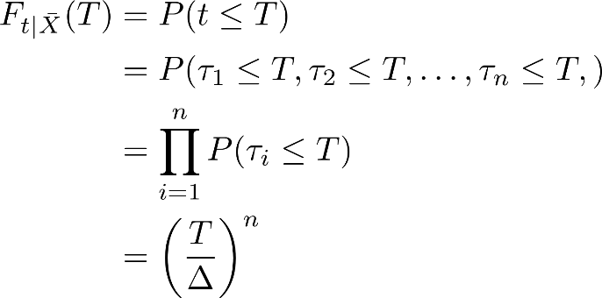 (25)

with $F_{t|\overline{X}}(T)$ denoting the conditional probability distribution function of $t$, given $\overline{X}$. Deriving (25) with respect to $T$, we get

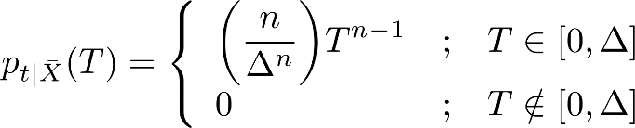 (26)

Considering (26), (23) and (22), it is possible to show that

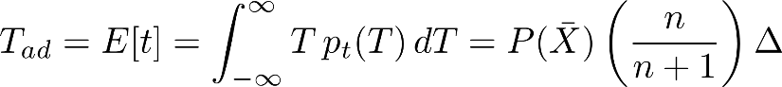 (27)

Finally, the normalized average admission time, defined as the ratio $T_{ad}/∆$, is given by

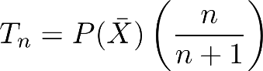 (28)

1. **Numerical Results**

The numerical results in this section are related to the specific scenario in which a WSD (say ${WSD}_{0}$), located at the center of the working region, is to be admitted into a network of WSDs already in operation. Each of the three procedures presented in Section 4, AP-Ecc.186, AP-Ofcom and AP-Iagg are examined. Two performance parameters are used to evaluate these procedures: the interference criterion attendance and the interference criterion attendance rate. They are considered in sections 5.1 and 5.2, respectively. For each considered admission procedure, estimates of the performance parameters are obtained by repeating the admission process in a Monte Carlo type of simulation implemented as indicated in the block diagram shown in Figure 8.

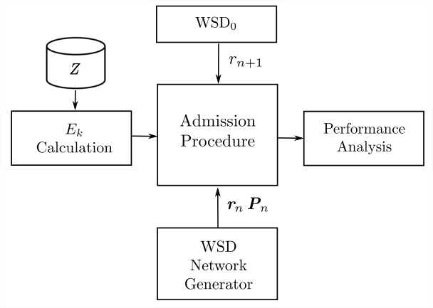

Figure 8. Block diagram for admission procedure simulation.

The simulation process begins by calculating the maximum regulatory e.i.r.p. values associated with each of the cells in the working region, as described in Section 3.1. The WSD Network Generator block provides a random sample of the WSD network (WSDs in operation), obtained according to the admission procedure in analysis. This sample is generated by adequately “thinning” and “marking” the sample of a homogeneous two dimensional Poisson point process - PPP [14] [15] [16]. The thinning operation uses the rules of the corresponding admission procedure to delete, in the PPP sample, points that do not satisfy the respective admission criterion. As a result, the locations of the $n$ admitted WSDs, characterized by a location vector $r_{n}$ is obtained. The marking operation then attaches, to each of the $n$ operating WSDs, an e.i.r.p. value that is operational and satisfies the admission procedure constraints, resulting in a e.i.r.p. vector $P_{n}$. This way, a sample of the thinned marked PPP is characterized by the pair $(r_{n}, P_{n})$. The admission procedure is then applied to WSD which is requesting admission ( ${WSD}_{0}$), located at geographical position $r_{n+1}$ in the central cell of the working region (Cell 0). In the Monte Carlo experiment, the whole process is repeated a large number $N_{R}$ of times.

The Performance Analysis block in Figure 8 is responsible for calculating the performance parameters and for producing performance comparative curves associated to admission procedures in analysis. The parameters used in the simulation are shown in Table 1.

Table 1. Parameters used in the simulation of admission procedures

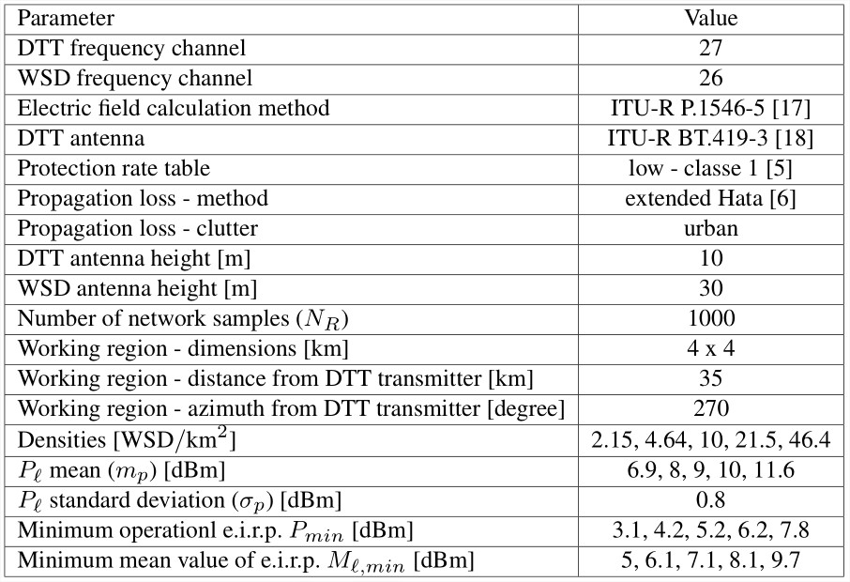

* 1. **Interference Criterion Attendance**

To verify the interference criterion attendance, the probability that the aggregate interference be greater than $Z_{MVC}$ is determined. Considering (10) and (11), this probability is given by

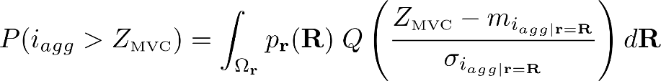 (29)

The integral in (29) is calculated by Monte Carlo simulation, considering that $p_{r}(R)$ is characterized by a thinned marked Poisson point process. Results corresponding to the three considered admission methodologies are presented in Figure 9, which shows $P(i_{agg}>Z_{MVC})$ as a function of the WSD density (in $WSD/{km}^{2}$). In the case of AP-Ofcom and AP-Iagg, the results are presented for different values of the WSD mean e.i.r.p. $m_{P}$. To indicate the interference criterion threshold, the level corresponding to $P\left(i_{agg}>Z_{MVC}\right)=0.01$ is also shown in Figure 9.

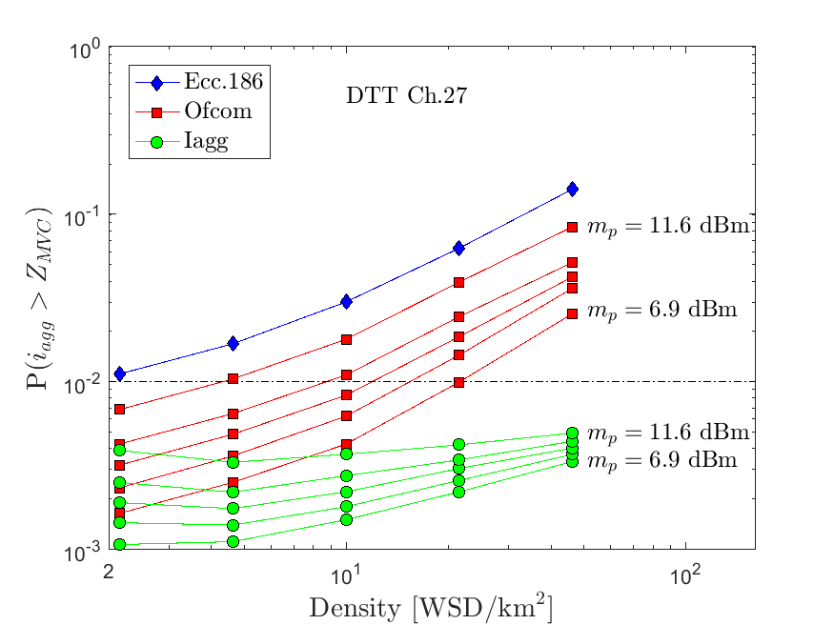

Figure 9. Probability that the aggregate interference power in Channel 27, due to WSD transmissions in Channel 26, be greater than intersystem interference reference power $Z_{MVC}$, as function of the WSD density.

Note that the interference criterion $P\left(i_{agg}>Z_{MVC}\right)≤0.01$ is not met by the Ecc.186 methodology for all WSD density values. The curves corresponding to the Ofcom methodology violate the interference criterion for WSD densities that are greater than 4.6, 8.8, 12.0, 15.0 and 21.0 for $m_{P}=$ 11.6, 10.0, 9.0, 8.0 and 6.9, respectively. In the case of the Iagg methodology, the aggregate interference criterion is met for all considered WSD densities and $m_{P}$ values.

* 1. **Interference Criterion Attendance Rate**

To determine the Interference Criterion Attendance Rate, a simulation process based on the block diagram in Figure 8 is used. Let then $N_{R}$ denote the number of times the admission procedure is applied to verify if ${WSD}_{0}$ can or cannot be admitted into the WSD network.

Note that, depending the admission procedure being considered, it is possible that ${WSD}_{0}$ be admitted without the aggregate interference criterion in (12) being met at the most vulnerable cell (MVC). This can indeed happen for AP-Ofcom and AP-Ecc.186. It is desired to evaluate the chances to have ${WSD}_{0}$ admitted and the aggregate interference criterion satisfied at the MVC. To do so, let $n_{a}$ denote the number of times, in $N_{R}$, that ${WSD}_{0}$ is admitted and the aggregate interference criterion is satisfied at the MVC. The Interference Criterion Attendance Rate (ICAR) is defined by the ratio $n_{a}/N_{R}$.

Curves of ICAR versus the WSD density, related to the three admission procedures defined in Section 4 are presented in figures 10 to 14 for different values of $m_{P}$ (AP-Ofcom and AP-Iagg) and $P_{min}$ (AP-Ecc.186). The associated values of the normalized average admission time $T_{n}$, given by (28), are also indicated in the figures.

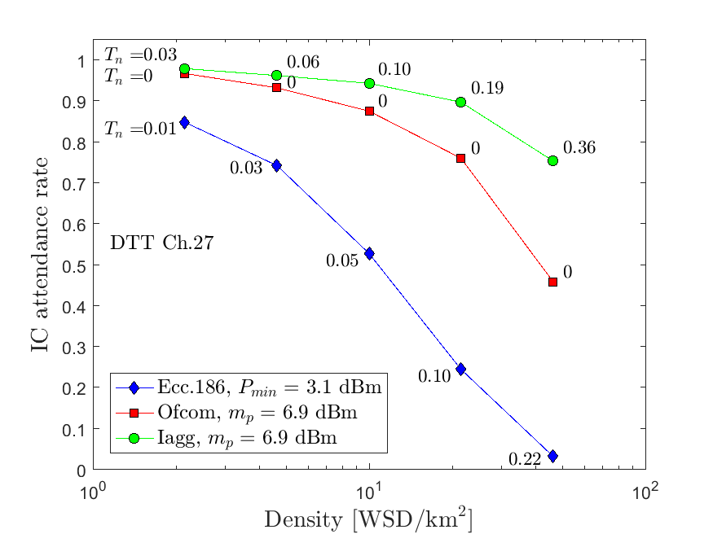

Figure 10. Interference criterion attendance rate as a function of the WSD density. (interference in DTT Channel 27 due to WSD transmissions in Channel 26; $m_{P}= 6.9$ dBm for AP-Ofcom and AP-Iagg; $P_{min}=3.1$ dBm for AP-Ecc.186).

Note that the ICAR curve related to AP-Ecc.186 is practically the same in all figures since it does not depend on $m_{P}$ (WSD e.i.r.p. value is deterministic) and, apparently, during the simulations ${WSD}_{0}$ e.i.r.p. $P_{0}$ was above the considered value of $P_{min}$. It reflects a weak performance for AP-Ecc.186, that can serve as a worst case reference for the evaluation of the other admission procedures. Observe that, for the AP-Ecc.186, the WSD admission almost collapses for a WSD density of 46.6 $WSD/{km}^{2}$ (ICAR close to zero).

From figures 10 to 14, it is possible to see that the performance of AP-Ofcom approaches that of AP-Ecc.186 as the mean e.i.r.p. $m_{P}$ increases. Also, when compared to AP-Ofcom, the AP-Iagg has a superior performance in all figures. This is due to the optimization procedure in AP-Iagg which, as indicated in Section 4, is a fundamental point in the Iagg admission procedure.

However, this performance improvement is obtained at the cost of an increase in admission time since, due to optimization process, WSD being admitted experiences a delay in admission time (the AP-Ofcom has no additional delay in admission time).

Note that, in AP-Iagg, the normalized average admission time $T_{n}$ increases with the WSD density and the mean value $m_{P}$ of the WSD e.i.r.p. This is indeed expected since the probability $P(\overline{M})$, that the aggregate interference is not met the criterion when the interference due to the WSD requesting admission is considered, should increase with the WSD density and with $m_{P}$.

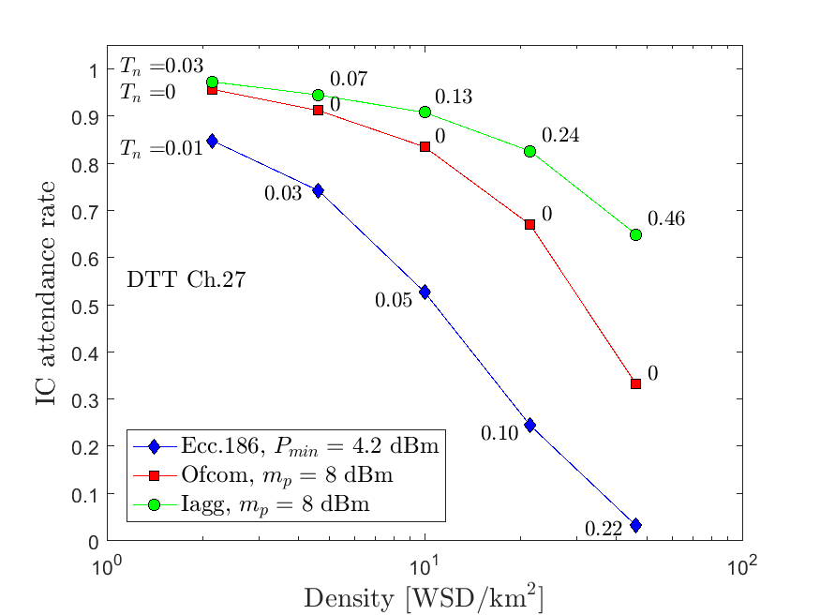

Figure 11. Interference criterion attendance rate as a function of the WSD density. (interference in DTT Channel 27 due to WSD transmissions in Channel 26; dBm for AP-Ofcom and AP-Iagg; dBm for AP-Ecc.186).

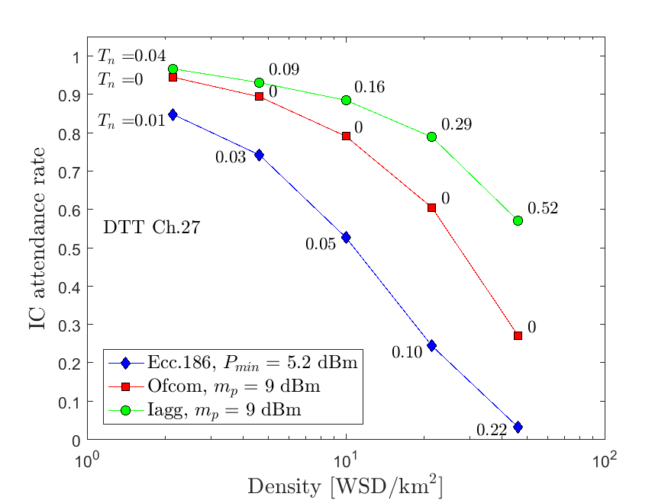

Figure 12. Interference criterion attendance rate as a function of the WSD density. (interference in DTT Channel 27 due to WSD transmissions in Channel 26; $m_{P}= 9$ dBm for AP-Ofcom and AP-Iagg; $P_{min}=5.2$ dBm for AP-Ecc.186).

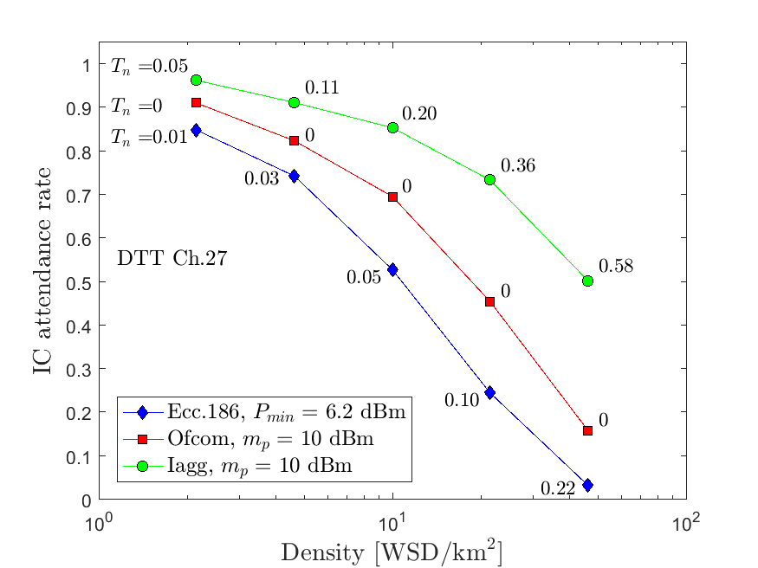

Figure 13. Interference criterion attendance rate as a function of the WSD density. (interference in DTT Channel 27 due to WSD transmissions in Channel 26; dBm for AP-Ofcom and AP-Iagg; dBm for AP-Ecc.186).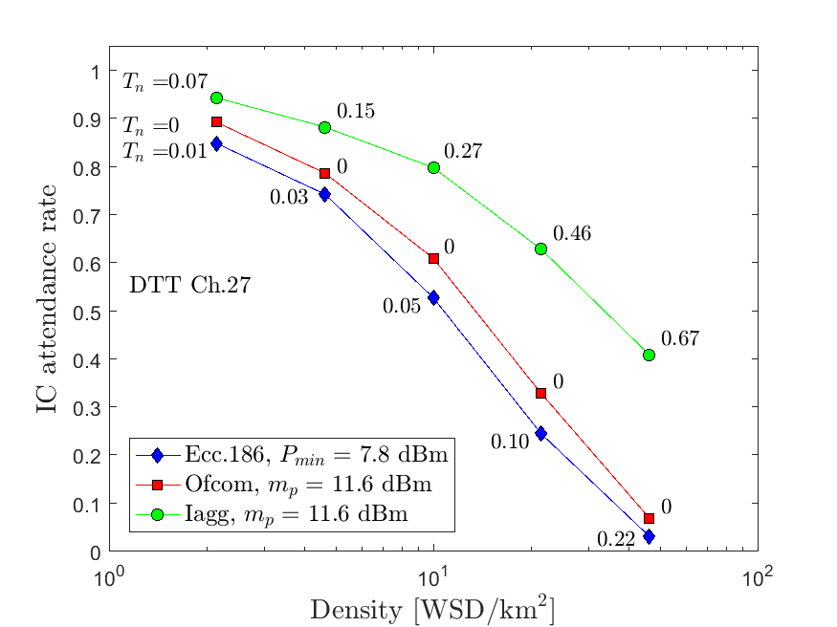

Figure 12. Interference criterion attendance rate as a function of the WSD density. (interference in DTT Channel 27 due to WSD transmissions in Channel 26; $m_{P}= 11.6$ dBm for AP-Ofcom and AP-Iagg; $P_{min}=7.8$ dBm for AP-Ecc.186).

1. **Conclusions**

This work has addressed the use of the terrestrial digital television (DTT) frequency bands by cognitive radio devices known as White Space Devices (WSD). In this scenario, a new methodology was proposed to define the transmission power of the WSDs and to ensure the protection of the digital TV receivers from the aggregate interference produced by the WSDs,.

The proposed methodology was tested using an admission procedure that was compared to two other procedures based, respectively, on Report Ecc.186 [1] of the Electronic Communications Committee of CEPT and on the regulation issued by the Ofcom [3]. The results have indicated a superior performance of the proposed admission procedure, obtained at the cost of an increase in admission time. A quantitative indication of these facts was presented in Section 5.

The admission procedures simulation demonstrated that the definition of interference thresholds through a single-entry interference approach is insufficient to ensure the protection of DTT receivers from harmful interference. The multiple-entry interference approach has been shown to be efficient in the protection of DTT receivers in this simulation.

The use of a database system (WSDB) for WSD admission allows the transmission power calculation of each new WSD on the network. The WSDB becomes an important network element that can include the calculation of the aggregate interference and also the transmission power adjustment not only to the new WSD, but also those WSDs that are already on the network working with wide margins.

In summary, the inclusion in regulations of the interference threshold based on aggregate interference, as well as the aggregate interference calculation and the transmission powers optimization when using database system, increases the protection of incumbent systems and, therefore, enables the adoption of opportunistic systems in the same band.

References

[1] ECC Report 186, ‘Technical and operational requirements for the operation of white space devices under geo-location approach‘, Electronic Communications Committee - ECC, January 2013.

[2] ECC Report 236, ‘Guidance for national implementation of a regulatory framework for TV WSD using geo-location databases ‘, Electronic Communications Committee - ECC, May 2015.

[3] Ofcom Statement, ‘Implementing TV white spaces‘, Ofcom, 12 February 2015.

[4] Lima, M.; Fortes, J. M.: ‘Aggregate interference from White Space Devices into digital television systems´, International Conference on Computing and Network Communications, December 2015.

[5] Ofcom Statement - Annexes 1 to 12, ‘Implementing TV white spaces‘, Ofcom, 12 February 2015.

[6] ECC Report 252, `SEAMCAT Handbook Edition 2, Annex 17: Propagation Models - A17.3 Extended Hata Model’, ECC, April 2016.

[7] Miller, S. L.; Childers, D.: `Probability and Random Processes: With Applications to Signal Processing and Communications - 2nd ed.´, Elsevier, 2012.

[8] Rappaport, T. S.: `Wireless Communications: Principles and Practice - 2nd ed. ´, Prentice-Hall, 1999.

[9] Schwartz, S.; Yeh, Y. S.: `On the distribution function and moments of power sums with log-normal components´, Bell System Technical Journal, September 1982.

[10] Ho, C.L., `Calculating the mean and variance of power sums with two log-normal components´, IEEE Transactions on Vehicular Technology, November 1995.

[11] Byrd, R.H., Gilbert, J.C., Nocedal, J., `A Trust Region Method Based on Interior Point Techniques for Nonlinear Programming´, Mathematical Programming, November 2000

[12] Waltz, R.; Morales, J.; Nocedal, J., et al., `An interior algorithm for nonlinear optimization that combines line search and trust region steps´, Mathematical Programming, July 2006

[13] Forsgren, A.; Gill, P.E.; Wright, M.H., `Interior Methods for Nonlinear Optimization´, SIAM Review, Vol 44, No. 4, pp. 525-597, 2002.

[14] Daley, D. J., Vere-Jones D.; `An Introduction to the Theory of Point Processes: Volume I: Elementary Theory and Methods - 2nd ed.´, Springer, 2003.

[15] Illian, J., Penttinen, A., Stoyan, H., \textit{et al}.; `Statistical Analysis and Modeling of Spatial Point Patterns´, Wiley, 2008.

[16] Chiu, S.N., Stoyan, D., Kendall, W.S., \textit{et al}.; `Stochastic geometry and its applications - 3rd ed.´, Wiley Series in Probability and Statistics, 2013.

[17] Recommendation ITU-R P.1546-5: `Method for point-to-area predictions for terrestrial services in the frequency range 30 MHz to 3 000 MHz´, 2013.

[18] Recommendation ITU-R BT.419-3: `Directivity and polarization discrimination of antennas in the reception of television broadcasting´, 1990